**ID:** 1

**Charter:** Rained-out tour

**Mission:** check action rollback

**Areas:** Sign in, photo

**Test Environment & URL:** IE 11, Windows 10, https://wildlife.by/

**Start date & time:** 20.10.2020

**Tester:** Kostukova Anna

**Duration:** supershort (30 min)

**Testing Notes:**

1. Start page
   1. Click the button “Вход”
   2. Fill the fields “Логин” and “Пароль”
   3. Click on the Cross button
2. Start page
   1. Click the button “Вход”
   2. Fill the fields “Логин” and “Пароль”
   3. Click on the Esc
3. Start page
   1. Click the button “Вход”
   2. Click on the “Забыли свой пароль?”
   3. Click on the Cross button
4. Start page
   1. Click the button “Поиск по сайту”
   2. Input any text in this field
   3. Click on the Cross button
5. Start page
   1. Click the button “Поиск по сайту”
   2. Input any text in this field
   3. Click on the Esc
6. Start page
   1. Click the button “Поиск по сайту”
   2. Input any text in this field
   3. Click on the Cross button
7. “Фотогалерея”
   1. Click on the any photo
   2. Click on the right arrow button

c. Click on the left arrow button

**Bugs:**

* + - 1. Login subpage: the password is erased, but the login is not when press Esc
      2. Login subpage: the password is saved, but password remains, If you delete the login and press esc

**Issues:** When logging in via VK, it returns an error (Screenshoot 1)

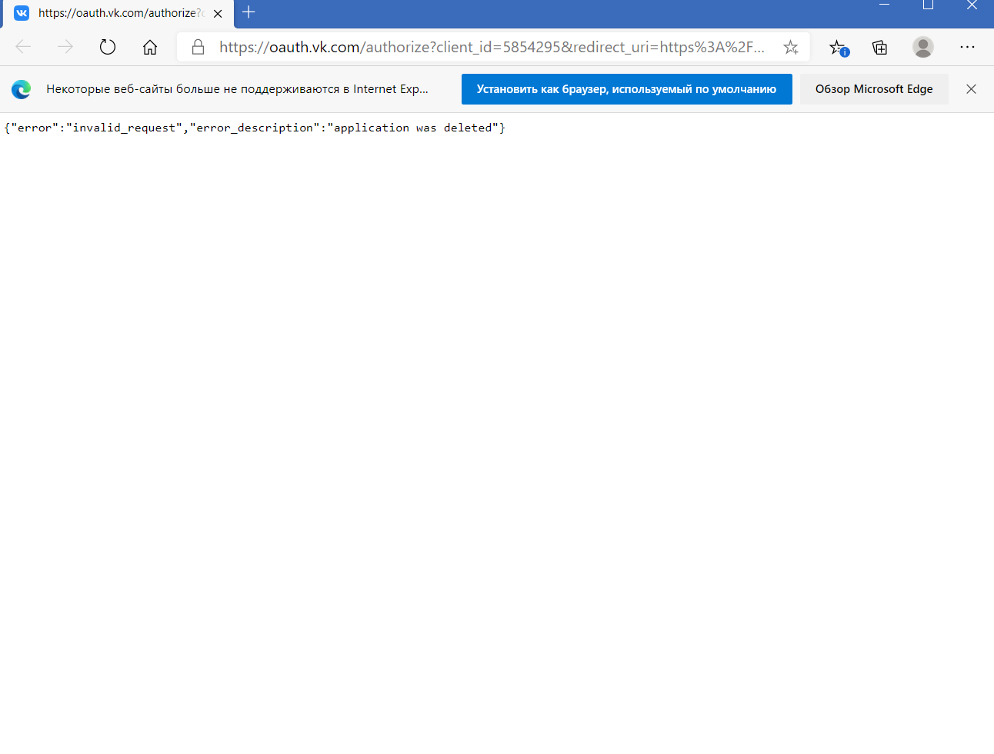

Screenshoot 1